OIST Graduate University Policies, Rules and Procedures

Authority:
- Approved by the President
- OIST School Corporation Act
- Private School Act
- School Education Act

Chapter 2. Governance and Organization

Official University Name
In accordance with Chapter II, Article 4, of the Bylaws of the Okinawa Institute of Science and Technology School Corporation (“the Corporation” or “SC”), the name of this graduate educational institution is

Okinawa Institute of Science & Technology Graduate University
(sometimes referred to as “OIST Graduate University” or “the University”).

All its academic activities shall be transacted, and all written academic instruments must be executed, in this official university name by its authorized officers and agents and authenticated, when necessary, by affixing the seal bearing the name Okinawa Institute of Science & Technology Graduate University [link: 2.7]. All business agreements, contracts, and other legally binding transactions required for OIST Graduate University must be executed in the official corporate name of the Okinawa Institute of Science and Technology School Corporation.

OIST School Corporation and OIST Graduate University, through the Board of Governors, reserve to themselves authority to approve:

      - Use, and revocation of the use, of the official corporate or university name or any abbreviated name by any non-University person or entity as part of its name or in any other manner that indicates or implies an authorized relationship with the University.

      - Removal of the official university name or any abbreviated name from the name of any organizational unit of the University.

      - Use of the official corporate or university name in a manner other than that prescribed in administrative policy.

2.1.2. Gifts, Bequests, Donations or Devises [link: 7].

All gifts, bequests, contributions, donations and devises made in trust or otherwise in the name of the University or any abbreviated name, or in the name of any unit of the University, shall be transferred to the Okinawa Institute of Science & Technology School Corporation. The Okinawa Institute of Science & Technology School Corporation has the authority to manage all transfers intended for the corporation.

2.1.3 University Marks [link: 15]. The University shall maintain a consistent visual identity system, including name, marks, and logos, that
(a) reinforces and protects the University’s identity; (b) distinguishes the University from other institutions; and (c) reflects the University’s traditions and heritage.

2.1.3.1 The President or delegate shall maintain administrative policies and procedures to implement this policy.

Board of Governors
The ultimate authority and responsibility for the management and operation of the OIST School Corporation lies with the Board of Governors (“BOG”). The BOG appoints a President for the OIST Graduate University. The President of the University serves as the CEO of the Corporation, pursuant to the SC Bylaws. The BOG appoints the Senior Level Executive who serves as the Vice-CEO of the Corporation, in accordance with the SC Bylaws. The SC Bylaws and the Rules for the Operation of the Board of Governors specify the purpose and activities of, and topics to be decided by the BOG. In general, the matters to be decided by the BOG concern management and operation of the School Corporation and the University. In particular, the BOG is required each fiscal year to review and approve the annual budget and business plan for the Corporation, which will have been prepared by the CEO/President, Vice-CEO, Provost, Secretary General, and Vice-Presidents in consultation with University faculty and staff. In all of its endeavors, the subjects to be deliberated may be accompanied by reports/opinions of the Board of Councilors.
2.2.1
The Board of Governors has an Office of the BOG. Secretary to the BOG acts as the Secretariat and works for the Chair of the BOG with the responsibilities for preparing agendas and papers for meetings, serving sub-Committees created by the BOG, managing the affairs of the BOG, and coordinating the activities with the Senior Level Executives and Faculty Council.

Board of Councilors.

The Board of Councilors (“BOC”) must prepare opinions on specified matters (such as budgets, borrowing, disposal of assets, donations, changes to the Bylaws) and submit them to the School Corporation CEO before meetings of the BOG to make decisions on the matters. The BOC also responds to inquiries from Governors, provides opinions to Governors, and solicits reports from Governors, regarding the state of the School Corporation’s operations and assets.

Roles and Responsibilities
The ultimate authority and responsibility for the management and operation of the OIST School Corporation (SC) lies with the Board of Governors (BOG).

President/CEO
The Board of Governors selects a President for the OIST Graduate University; the President also serves as the Chief Executive Officer (CEO) for the School Corporation. The President, in consultation with the BOG, establishes a management structure for the University. That structure must effectively and efficiently facilitate the development, maintenance, operation, and growth of a renowned international graduate university that promotes outstanding achievement in science and technology through education and research and contributes to the self-sustaining development of Okinawa. The management structure must also ensure administrative and fiscal accountability and provide transparent oversight regarding use of government and private funds.

The BOG entrusts the day-to-day operations of the School Corporation and the Graduate University to the CEO/President, including
- management of the University and all its departments, operation of the
physical plant, and administration of the University’s business activities;
- preparation of annual University operating and other budgets, which must be submitted to the BOG for review and subsequent action; and
- preparation and submission of periodic plans and reports to the BOG on the status of plans and projections and various other reports as needed.

One Senior Level Executive who is appointed by BOG; by the provision of the SC Bylaws, also serves as the Vice-CEO of the School Corporation. The President may appoint, and prescribe the powers and duties of, other officers and employees that the President may deem appropriate to assist in the performance of Presidential duties and responsibilities.

The President is further responsible, directly or by delegation, for establishing and maintaining administrative policies and procedures to

assure the carrying out of these responsibilities.

      - Tokyo Office Director
Tokyo Office Director is responsible for strengthening relationships in Tokyo with Japanese and foreign political, industrial, and academic circles to expand the presence and activities of OIST at home and abroad through science, technology, and innovation (excluding responsibilities and duties of other divisions).

      - Senior Advisor to the President for Institutional Development
The Senior Advisor for Institutional Development is responsible for cultivating and developing connections with relevant U.S.-Japan networks both in Japan and the U.S., and establishing a foundation for future fundraising activities for the University.

General Counsel
The General Counsel provides legal opinions and advice in regard to the University’s policies/business, risk managements, conflicts/disputes cases and contracts related matters and represents the University in legal matters concerning external entities. The President may permit the General Counsel to use a title of Vice President for Legal Affairs.

Chief Information Officer (CIO)
The Chief Information Officer (CIO) is responsible for promoting coherence and efficiency through university wide information technology (IT) strategy, and information security programs. The CIO is also responsible for conducing special programs or information related initiatives at the discretion of the President.

2.4.1.4.1 The CIO delegates the development and enforcement of the information security program to the Chief Information Security Officer (CISO).

Chief Compliance Officer (CCO)
The Chief Compliance Officer (CCO) conducts the audit based on the annual audit plan or on a temporary basis. The CCO reports those results to the CEO/President.

      - Ombudsperson
The Ombudsperson provides confidential, neutral, independent and informal assistance, such as listening, offering information and examining options for resolving concerns, to employees and students who have concerns arising from their work or studies at OIST.

Vice-CEO
The President nominates, and the Board of Governors appoints, the Senior Level Executive who also serves as the Vice-CEO of the School Corporation.

The Vice-CEO shall support the duties of the CEO or perform the duties of the CEO by proxy in the event that he/she is indisposed or absent. For long-term incapacity or absence of the CEO, the Board of Governors may appoint an Acting CEO from the Governors in accordance with Paragraph 2 of the Article 13 of SC Bylaws.

Auditors
Auditors of the School Corporation (SC) are nominated by the BOG from among individuals who are not Governors, not employees of the University and not Councilors; the BOC must concur in the nomination, and the CEO must appoint the Auditors. The appointment becomes effective only upon approval by the Prime Minister. Auditors are responsible for auditing SC operations and asset condition, and for reporting on these matters to the BOG and the BOC following the close of each fiscal year. Auditors attend BOG meetings and express opinions on the SC’s operations and asset condition. If, as a result of their audits, Auditors discover violations of bylaws or illicit activities concerning the SC’s operations or assets, they must report these discoveries to the BOG, among others.

Provost and Secretary General

2.4.4.1 Provost
The Provost shall represent the University for academic and research matters. The Provost is in charge of interdepartmental coordination between the Dean of Graduate School, the Dean of Faculty Affairs and the Dean of Research in terms of academic affairs and has the authority to allocate resources and manage necessary resources, such as administrative support for concluding agreements with external academic partners. The Provost is also responsible for Research Support Services with Core Facilities, and overall research support functions required for research activities (excluding the items that are under the responsibility of the Dean of Faculty Affairs).

2.4.4.1.1 Assistant Provost for Administration
The Provost may have the Assistant Provost for Administration conduct the duties in part of the administrative matters and financial management.

2.4.4.1.2 Director of Core Facilities

The Provost may have the Director of Core Facilities conduct the duties in part of the management of Core Facilities.

2.4.4.1.3 Senior Manager for Research Resources
The Provost may have the Senior Manager for Research Resources conduct the duties in part of the management of research resources allocation.

2.4.4.2 Secretary General
The Secretary General shall assist the President and serve as the final authority on all administrative matters. The Secretary General oversees all administrative functions, including financial management, human resources, facility management, information technology. The Secretary General is also responsible for occupational health and safety for employees and students and risk management of the School Corporation.

Associate Vice President (SG Office)
The Secretary General may have the Associate Vice President in SG Office conduct the duties in part of governmental relations, rules and procedures, and compliance.

        - Emergency Response Coordinator
The Secretary General may have the Emergency Response Coordinator conduct the duties in part of the Safety Management on the whole university level.

Vice Presidents
The following university officers serve as Vice Presidents (including Deans) of the University as represented in the University Organization Chart in 2.5 below. Each Vice President is assigned an annual budget, with full authority to administer the budget for which they are held responsible by the President.

Dean of the Graduate School
The Dean of the Graduate School (DGS) is responsible for providing services and programs that support the full cycle of attending the Graduate School at OIST Graduate University. Thus the Dean of the Graduate School is responsible for all elements of planning and support that start with admission and end with graduation and the initial post-graduate placement. The Dean of the Graduate School is responsible for all aspects of the graduate school curriculum including the assignment of faculty to teach the graduate courses.

Vice Dean of the Graduate School
The DGS may delegate duties to Vice Dean.

Dean of Faculty Affairs

The Dean of Faculty Affairs (DFA) is responsible for administration of general matters concerning the recruiting, appointment and evaluation of faculty and personnel in research units and other groups, including visiting programs. The DFA is in charge of academic and scholarly management in coordination with other Deans and the Provost. The DFA is also responsible for the operation of University Library and the Center for Professional Development and Inclusive Excellence (C-Hub).

Vice Dean of Faculty Affairs
The DFA may have the Vice Dean of Faculty Affairs conduct the duties in part.

Dean of Research
The Dean of Research is responsible for developing a network with other universities and research institutions on academic and research matters. The Dean of Research is also responsible for grant applications and management (excluding the grants managed by the Executive Vice President for Technology Development and Innovation).

2.4.5.3.1 Vice Dean of Research

The Vice Dean of Research (Vice Dean of Research: VDR) deputizes for the Dean of Research in (i) developing collaborative networks with other universities and research institutions on academic and research matters and (ii) directing grant application and management (excluding the grants managed by the Executive Vice President for Technology Development and Innovation).

Executive Vice President for Technology Development and Innovation
Executive Vice President for Technology Development and Innovation administers the functions that support the University mission to further the self-sustaining development of Okinawa. Key elements of this mission are management of intellectual property, technology transfer and business development.

- Associate Vice President for Technology Development and Innovation
The Executive Vice President for Technology Development and Innovation may have the Associate Vice President for Technology Development and Innovation conduct the duties in part.

- Vice President for Financial Management
The Vice President for Financial Management (VPF) is responsible for all aspects of the University budgets and the accounting against such budgets. The VPF is responsible for procurement, which includes tenders, routine procurements and internal supply lines.

Vice President for Buildings and Facilities Management
The Vice President for Buildings and Facilities Management (VPBFM) is responsible for all aspects of new construction, from the planning through procurement, to contract management, to physical constructions and completion of the facility. The VPBFM is responsible for all aspects of building, facility and site maintenance, including modifications made to University buildings.

Vice President for Communication and Public Relations
The Vice President for Communication and Public Relations (VPCPR) is responsible for public relations in its broadest sense, be it interactions with local, Okinawan, national, or global communities. The VPCPR is responsible for all aspects of media and press. The VPCPR is responsible for the logistics of University events, including workshops, symposia, colloquia, celebrations, and public events.

Vice President for Human Resource
The Vice President for Human Resource (VPHR) is responsible for overall management of Employment and Employee Relations Management, Labor Management Agreement, Talent Development, Training and Education, HR Management, Recruiting and Relocation, to enhance productivity of the diverse workforce, to promote diversity, and to improve work-life balance at OIST.

- Vice President for Information Technology
The Vice President for Information Technology (VPIT) is responsible for ensuring that IT services are appropriately architected, implemented and maintained. The VPIT is responsible for ensuring IT remains engaged with all areas of the University, and that IT services are developed to support the programs and policies set by the CIO.

2.4.5.10 Vice President for Strategy Implementation
The Vice President for Strategy Implementation supports the delivery of the university’s goals with a special emphasis on diversity, equity, and inclusion; coordinates cross-functional strategic planning processes and projects.

2.4.5.11 Vice President for University Community, Child & Youth Services
The Vice President for University Community, Child & Youth Services (VPUCS) is responsible for providing campus-wide community services that will enhance the lives of all faculty, staff, students and their families at the University.

Committees

The University may rely upon committees, standing and ad hoc, internal and external, whenever needed to assist in carrying out various functions or to provide advice regarding selected topics. Whatever their purpose, such committees must be operated in accordance with the Terms of Reference regarding formation, composition and organization of each committee. To create the Terms of Reference, refer to the Terms of Reference example. Details concerning the payment of honoraria and other expenses for external committee members may be found in Chapter 26, Finance & Accounting, Appendices.

Organization Chart

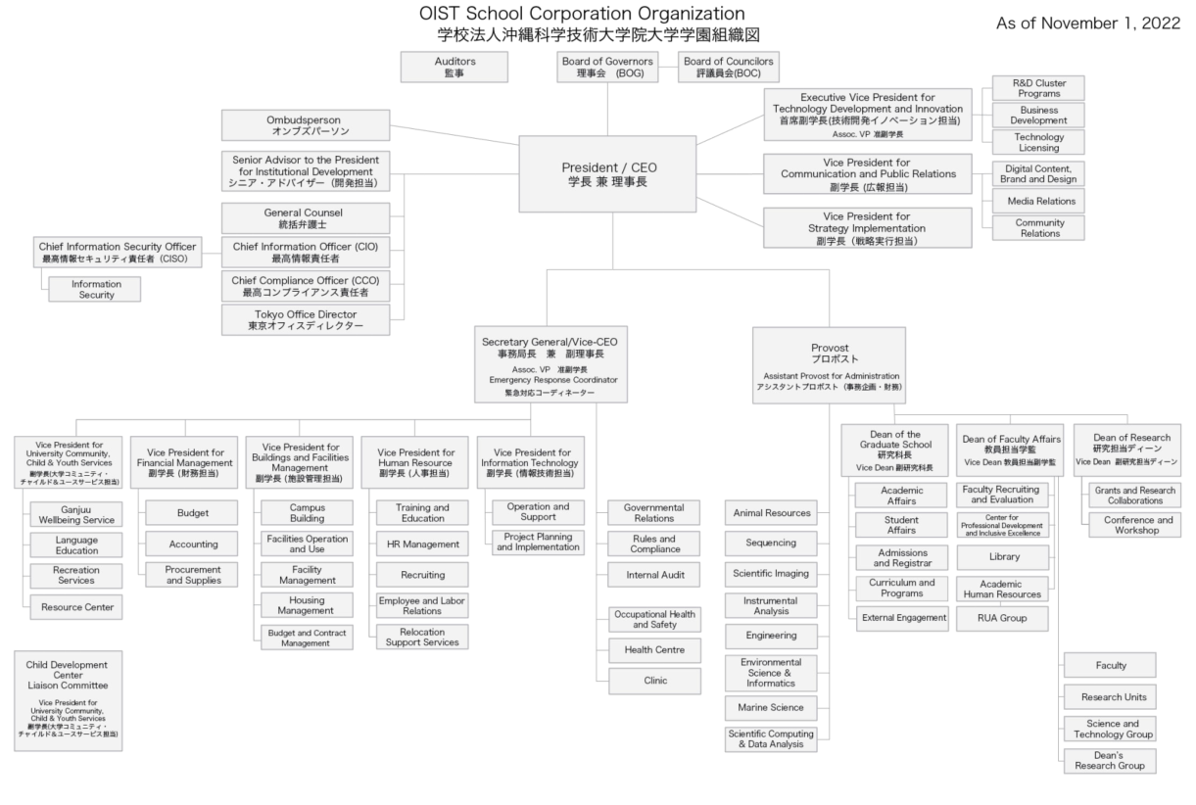

    - Detailed Charts
The CEO/President, the Vice-CEO, Provost, Secretary General and the Vice Presidents are responsible for developing more detailed organization charts for those units that they head. Those detailed organization charts [link] shall be approved by the CEO/President and internally published with a description regarding responsibilities and duties of each group/section/units.

2.5.2 Reorganization of the Structure
When the organization of OIST is to be restructured, the proposal of the new structure shall be approved with kessai by the CEO/President 14 days prior to the effective date.

CEO/President’s Delegation of Authority
As authorized by the Board of Governors, the President/CEO may delegate executive management and administrative authority to the University's Senior Level Executives. The CEO/President's delegations of authority authorize the Senior Level Executives to act on behalf of the Corporation/University in the name of the CEO/President and to bind the Corporation/University within the scope of the delegated authority to a legally enforceable obligation. The CEO/President may condition, limit, or revoke any authorities so delegated at any time. Authority reserved by the CEO/President may not be exercised by any other person.

Delegation of authority does not permit those so privileged to violate spending or signature thresholds established by the CEO/President for fiscal and administrative control.

Sub-Delegations of the CEO/President's Authority.

Senior Executives who have authorities delegated to them by the CEO/President may, but need not, sub-delegate authorities to employees who report to them and so on throughout the organization. The Senior Executives are ultimately responsible and accountable for the proper sub-delegation of the CEO/President's authorities throughout their units, in accordance with this policy. For purposes of this Chapter, the person who delegates authority to others is a “Delegating Official” and the person who receives a delegation of authority is a “Delegate.”

Responsibilities of Delegates

      - Delegates may further delegate any delegated authority if it is not expressly disallowed or limited in any way. However, unless further delegation is required, delegates may reserve to themselves any authority delegated to them.

      - Delegates below the level of Vice President must obtain approval from the Delegating Official in order to sub-delegate any authority delegated to them.

      - Delegates may not delegate greater responsibility and decision-making authority than they have been delegated, and may not delegate authority to anyone who has an individual or institutional conflict of interest related to that authority, as defined by University policy [link: 22].

      - Employees with delegated authority must act only within the scope of that delegation. Employees who act outside the scope of their authority and do not have documented authority to do so may be subject to disciplinary action, up to and including termination.

      - Delegates remain responsible and accountable at all times for the exercise of any authority they choose to sub-delegate to others.

Requirements for Delegation

      - Delegated authority must be granted and exercised consistent with the terms and conditions of the original delegation and with all applicable laws and University policies.

      - Delegating Officials must delegate authority only to persons who are current University employees, who have some level of responsibility for the activity being conducted, who are knowledgeable about University policies, rules, laws, regulations and procedures, and over whom the Delegating Official has management authority. All delegations become null and void upon the last date of employment.

      - Delegating Officials must provide copies of their delegations of authority (new or revised) to the Secretary General and to the General Counsel.

      - For annual budget authority, a delegation of authority is deemed complete once the budget is allocated on the ERP system. Any other delegation of authority must be made in writing.

      - Delegating Officials must retain documentation of all of their delegations, and review those delegations at least annually, via the performance evaluation process, to ensure they are up-to- date and appropriate. This documentation must be made available upon request.

2.6.4. Ambiguities involving Delegations of Authority. In the event that there is an ambiguity or an inconsistency involving delegation assignments, the CEO/President or his/her delegate will determine who has the ultimate authority.

Use & Management of Seals

    - Definition
In this paragraph, the meanings of the terms listed in the following items are as prescribed respectively in those items.

(i) Official seal
A seal used for documents such as contracts and agreements created by the University, and the purpose of which is to certify the authenticity of such documents by affixing the seal.
(ii) Signature
A document created by the University, such as a contract or agreement, is signed by an employee who has the authority to create the document on his or her behalf for the purpose of certifying that the document is authentic.
(iii) Digital signature
A digital signature as defined in Article 2, Paragraph 1 of the Act on Electronic Signatures and Certification Business (Act No. 102 of 2000), whose use is intended to have the same effect as an official seal.
(iv) Electronic contract system
An information system or information service that can objectively verify the conclusion of a contract by digital means such as digital signatures or time stamps, and that enables the conclusion of a contract by digital means through the exchange of digital information via a communication line.
(v) Official seal, etc.
Refers to those listed in the following items.
a. Official seal
b. Signature
c. Digital signature
d. Electronic contract system

    - Production and Custody
2.7.2.1 Any of University/Corporation’s official seals and digital signatures shall be produced by the Secretary General and registered in a registry (Official Seal Registry) developed and maintained by the Secretary General.
Any of the University/Corporation’s official seals and digital signatures are in the custody of the Secretary General or the officials that are registered in the Official Seal Registry with an approval of the Secretary General (hereinafter referred to as “Official Seals Management Supervisor”).
Any official seals, etc. shall be kept with utmost care in accordance with the guidelines developed by the Secretary General (hereinafter referred to as “Guidelines for Management of Official Seals.”).

    - Use of Seals, etc.
The Official Seals Management Supervisor shall follow the provisions of the Guidelines for Management of Official Seals. when using official seals.

      - Copy of Seal Impression
With a prior approval by the Secretary General, the impression of official seals may be copied or electronically inserted, when issuing standardized documents, such as ID cards and certifications or issuing a large number of documents with the same contents.

      - Signatures
A signature by a person authorized to create a document may be used to verify the authenticity of the document in substitution for official seals.

2.7.3.3 Digital Signature
A digital signature may be used in place of a regular seal or signature provided that the other party to a contract or agreement can be signed by a digital signature and that there is an agreement between the University and the other party to that effect.

2.7.3.4 Electronic Contract System
If the electronic contract system used by the University (such systems that meet the technical and legal requirements of the University and are used by the University as standard. However, excluding general-purpose information systems such as e-mail) is used for entering into contracts and agreements, it is not necessary to use official seals, signatures, or digital signatures. However, when using an electronic contract system used by the other party to a contract or agreement, a contract or agreement may be entered into only if the conditions specified in the Guidelines for Management of Official Seals. are met.

2.7. 3.5 Omission of Official Seals
Affixing official seals may be omitted if specified in the Guidelines for Management of Official Seals.

